Activity and State Diagrams
Tenant
FR1- Update personal information (Done by: Anisa Domi)
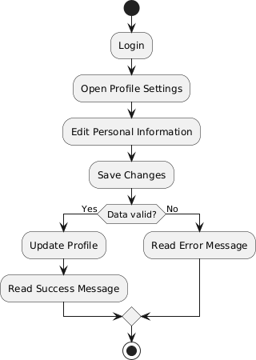

FR2 - Search properties (Done by: Anisa Domi)
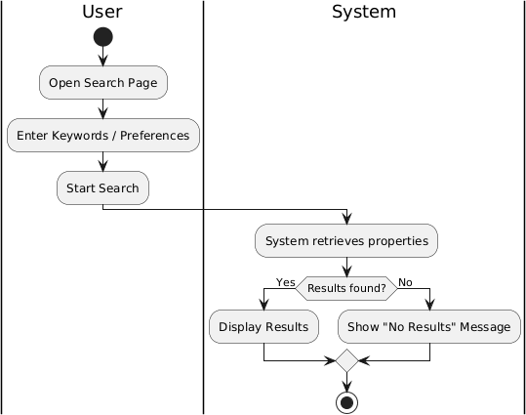

FR3 - Filter properties (Done by: Anisa Domi)

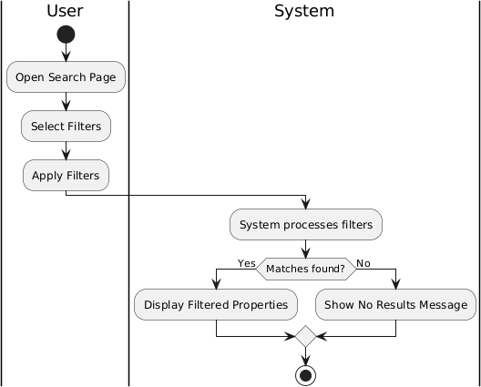

FR4 - View property details and booking history. (Done by: Anisa Domi)

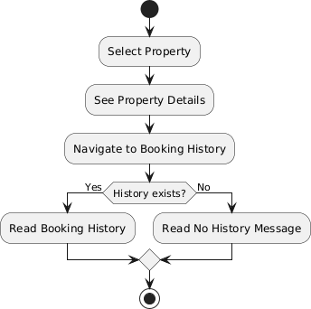

FR5 - Send rental requests and message to property owners. (Done by: Anisa Domi)

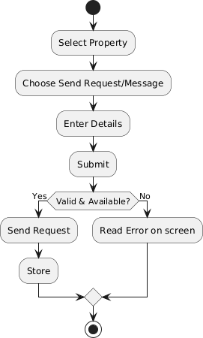

FR6 - Cancel rental request (Done by: Anisa Domi)

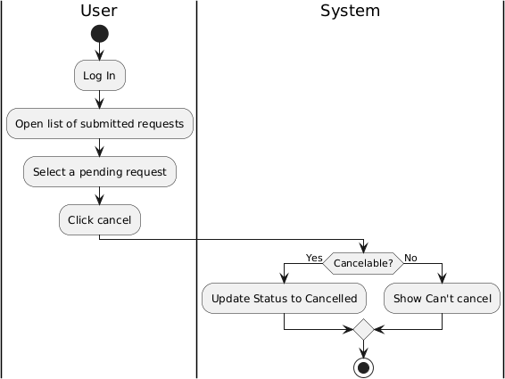

FR7 - Receive messages from property owners. (Done by: Haidi Toto)

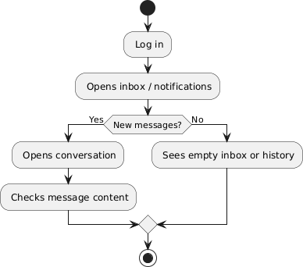

FR8 – Submit rental payments. (Done by: Haidi Toto)
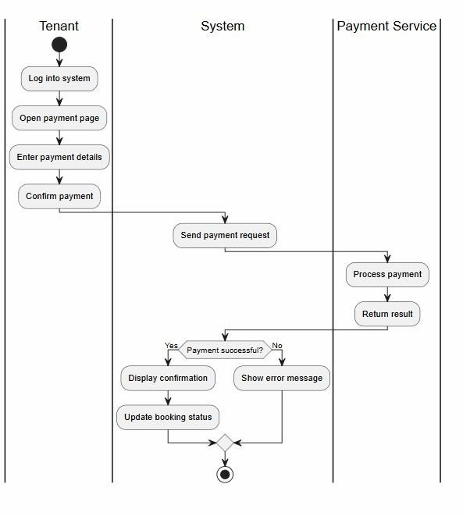

FR9 - Save favourite properties for later viewing. (Done by: Haidi Toto)

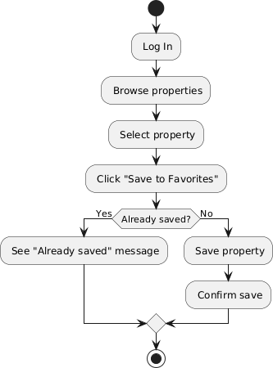

FR10 – Review and Rate property (Done by: Haidi Toto)

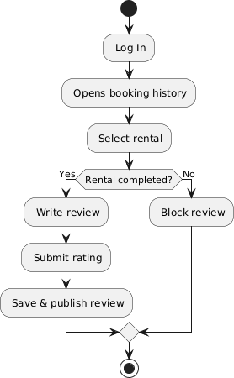

Property Owner
FR11 - Update Profile Information and availability of rental properties (Done by: Haidi Toto)
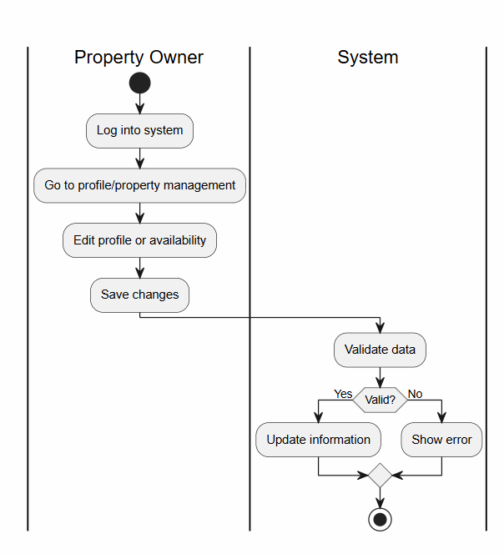

FR12 - Add Property Listing (Done by: Haidi Toto)
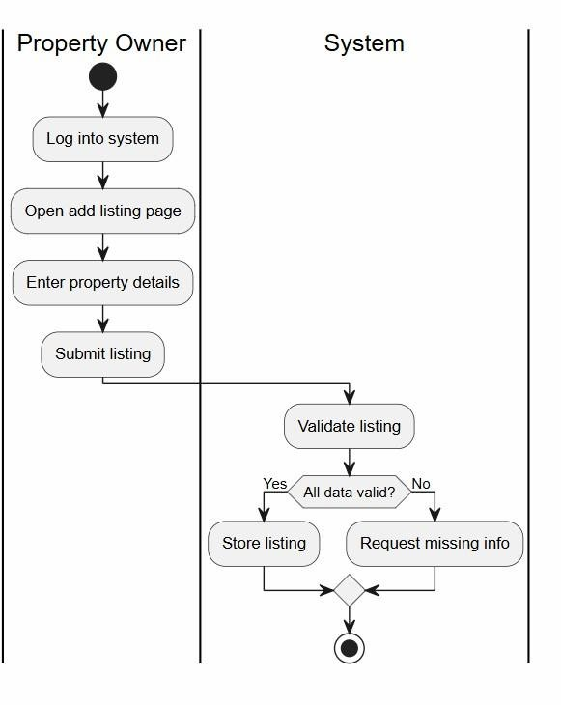

FR13 - Upload Property Images (Done by: Ledio Tafciu)
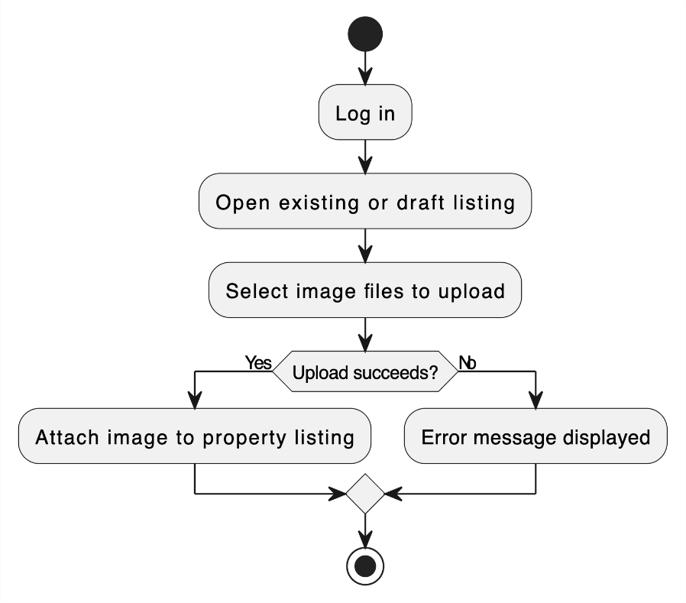

FR14 - Edit Property Listing (Done by: Ledio Tafciu)

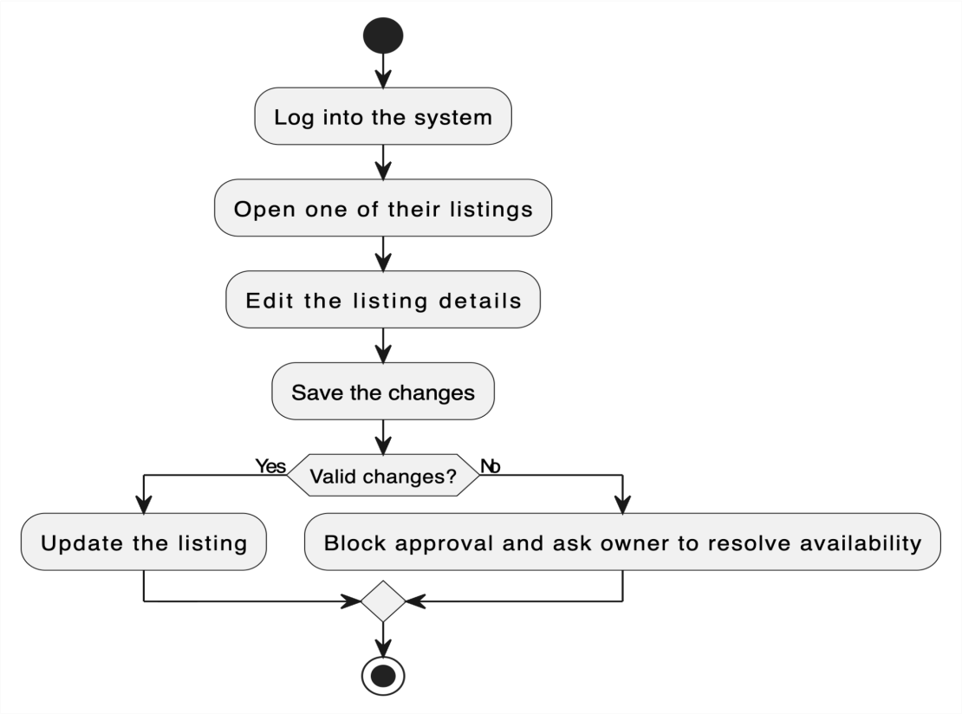

FR15 - Delete Property Listing (Done by: Ledio Tafciu)
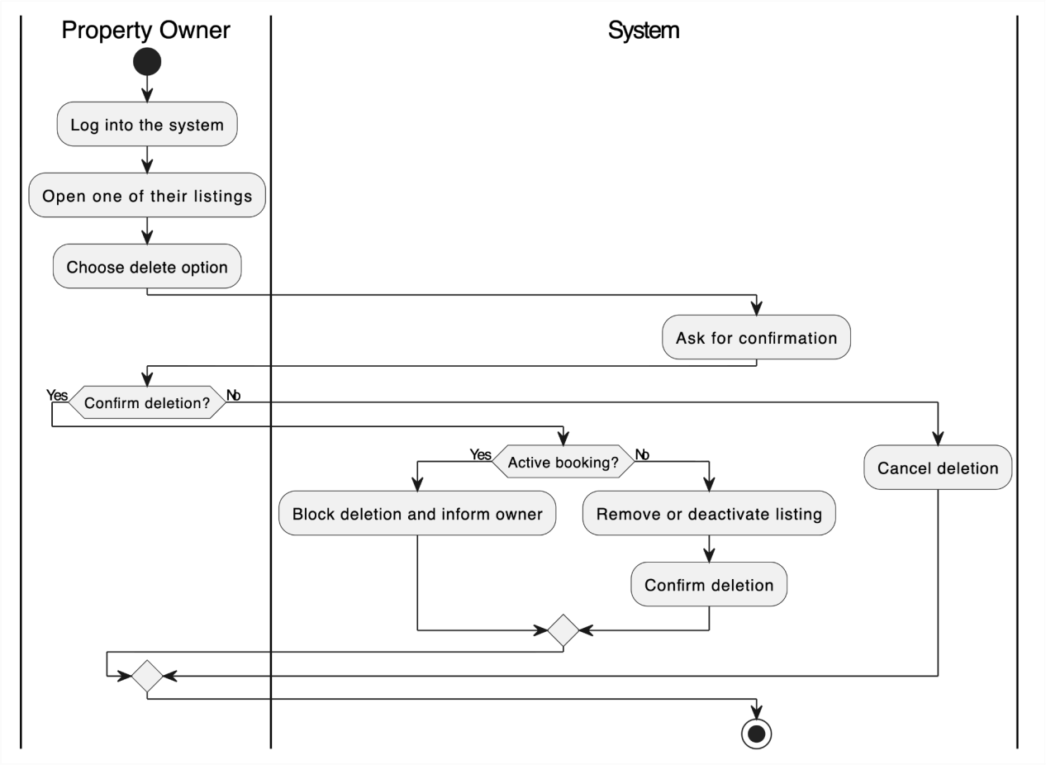

FR16 - View Rental Requests (Done by: Ledio Tafciu)
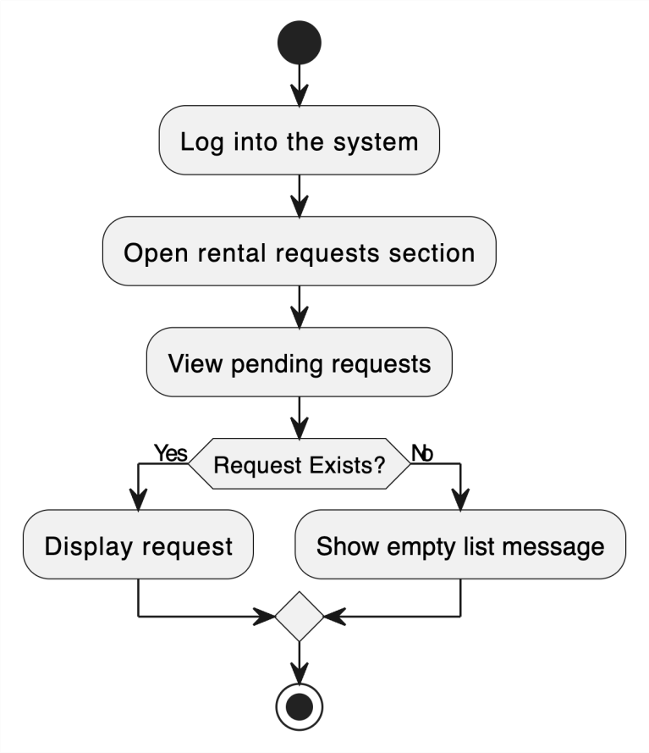

FR17 - Accept or Reject Rental Request (Done by: Ledio Tafciu)
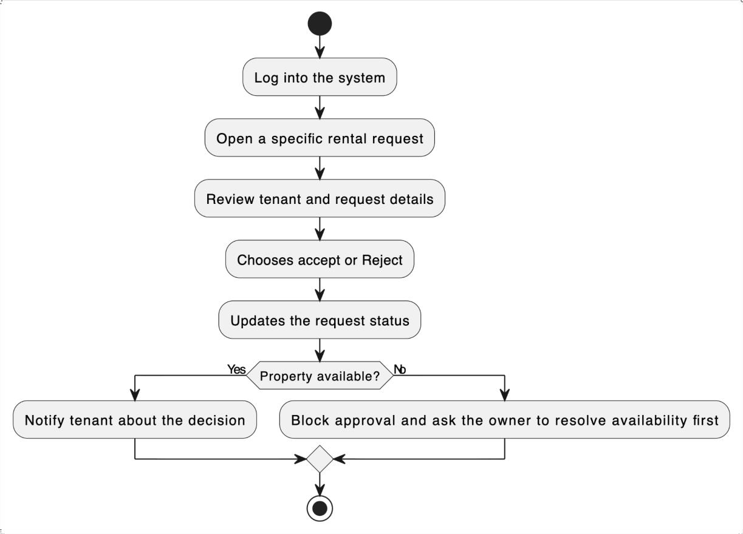

FR18 - Send Message to Tenant (Done by: Ledio Tafciu)
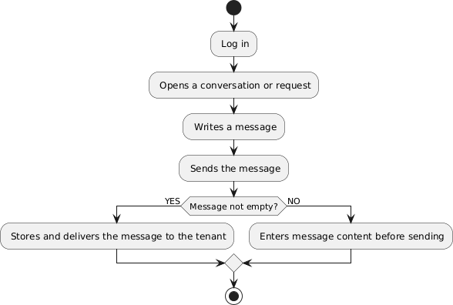

FR19 - View Booking History (Done by: Desard Lybeshari)

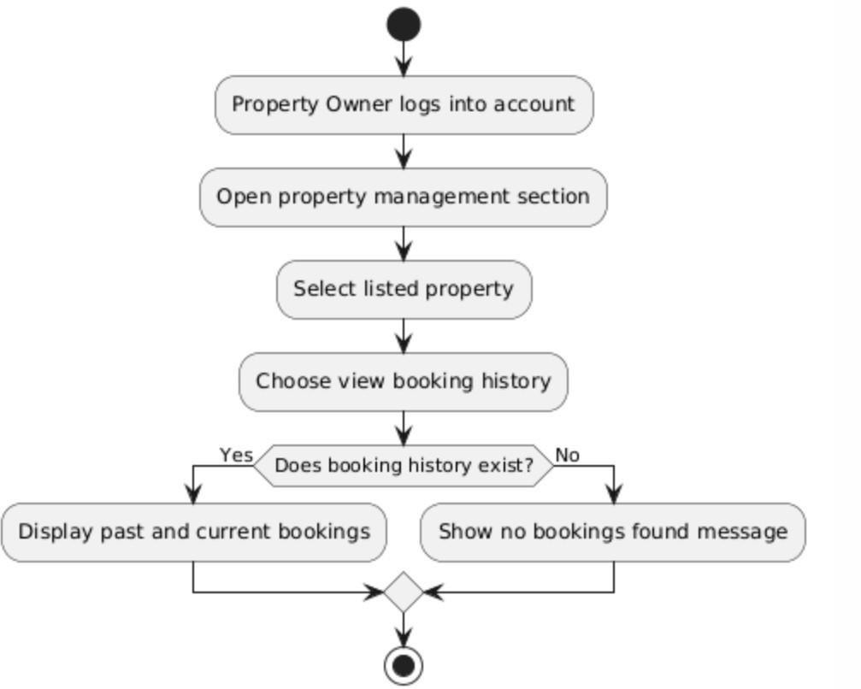

FR20 - Mark Property as Unavailable or Rented (Done by: Desard Lybeshari)

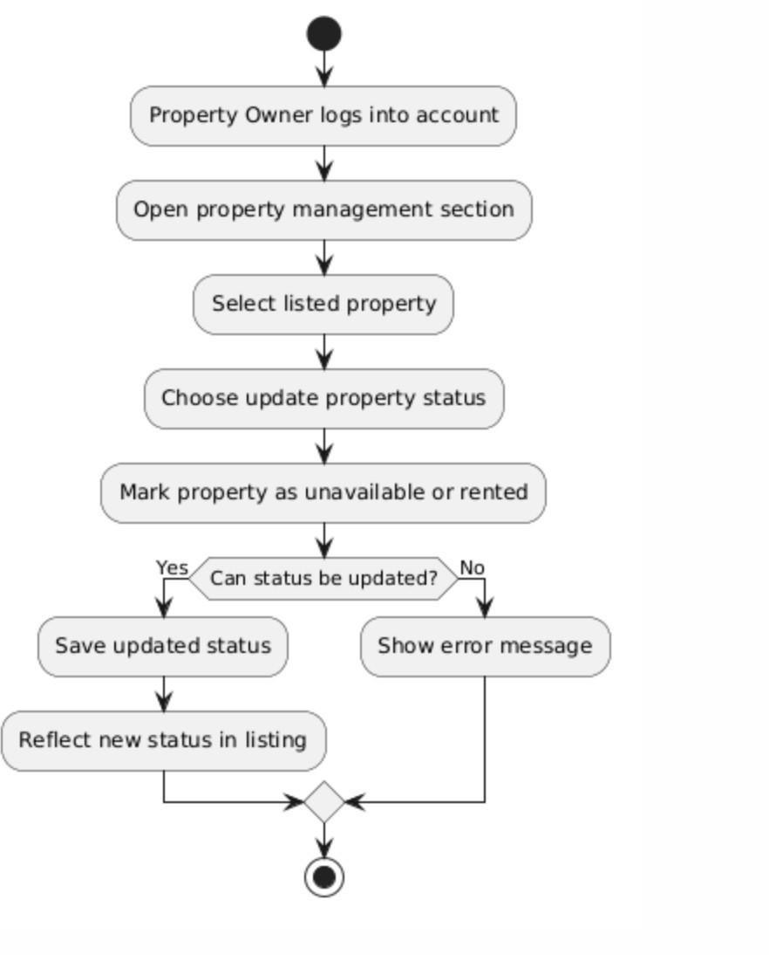

Administrator
FR21 - Edit User Accounts (Done by: Desard Lybeshari)
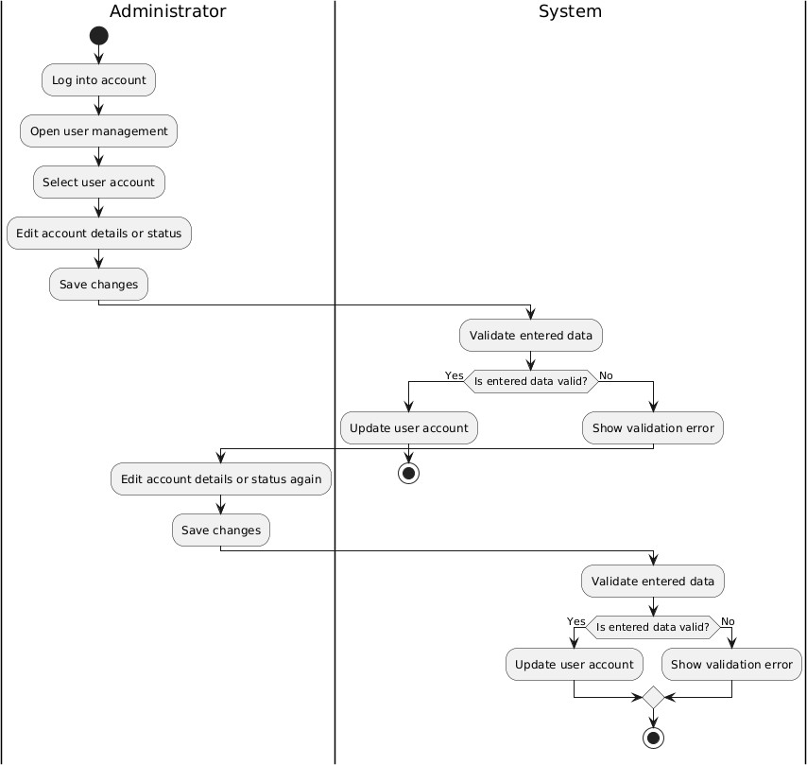
FR22 - Delete User Accounts (Done by: Desard Lybeshari)

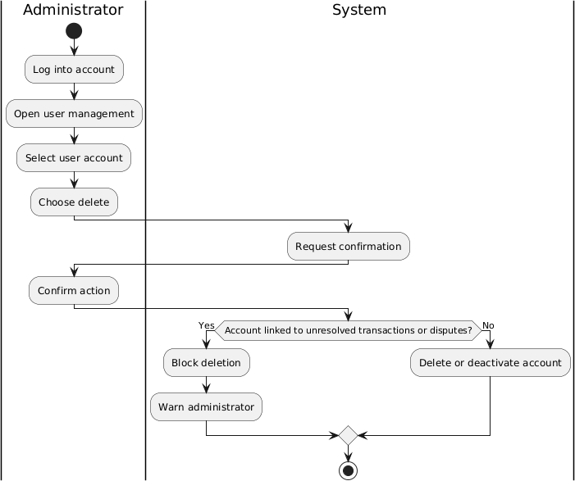

FR23 - Monitor Rental Transactions (Done by: Desard Lybeshari)

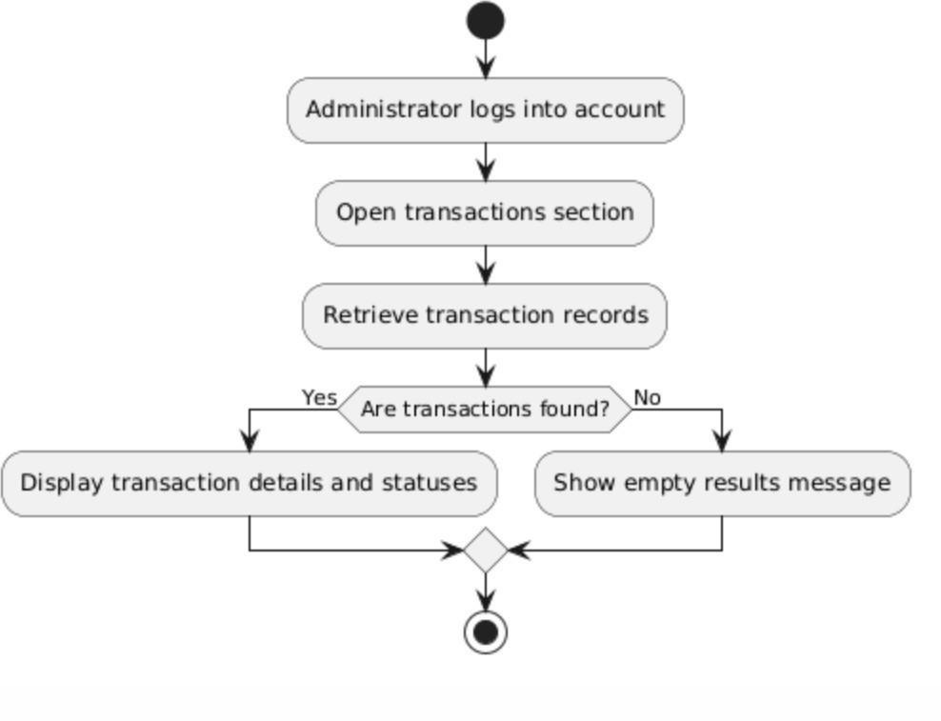

FR24 - View System Reports and Property Listings (Done by: Desard Lybeshari)

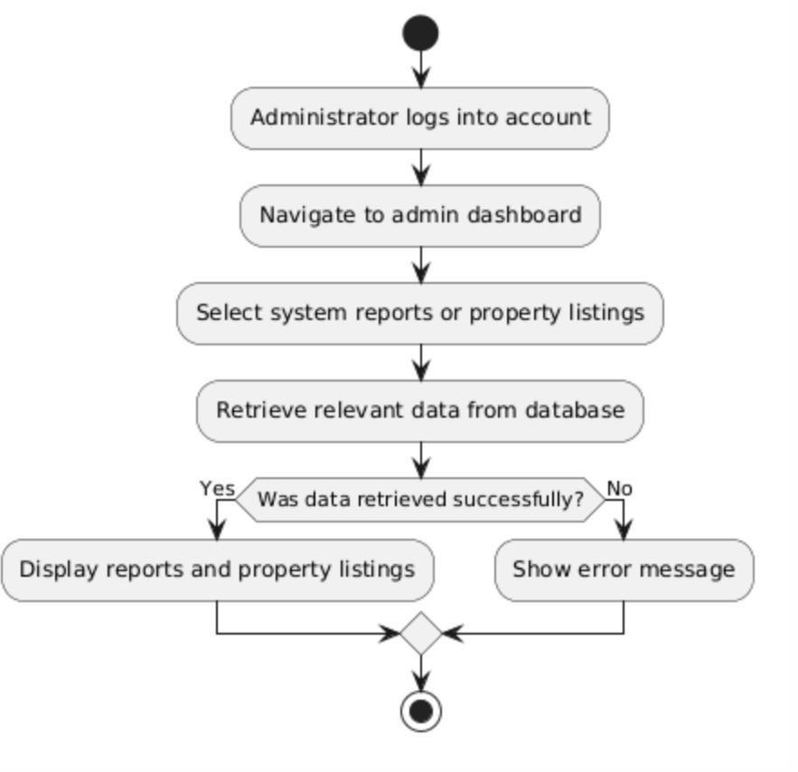

FR25 - Remove Inappropriate Listings (Done by: Matias Bali)

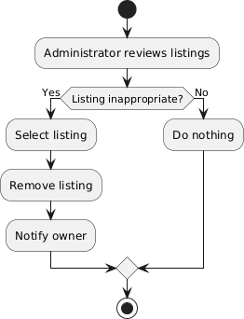

FR26 - Manage Disputes and System Settings (Done by: Matias Bali)
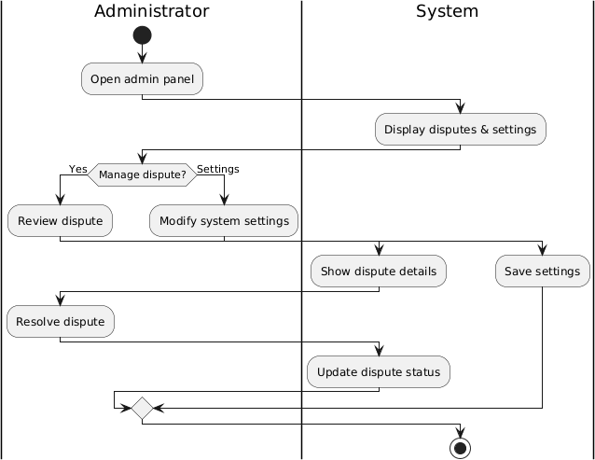

FR27 - Restore User Accounts (Done by: Matias Bali)
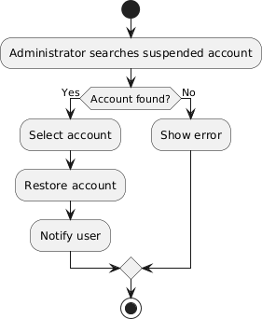

FR28 - Suspend User Accounts (Done by: Matias Bali)
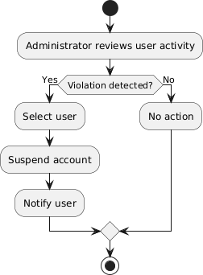

FR29 - Verify and Approve property listings (Done by: Matias Bali)
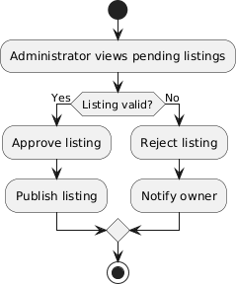

Manager
FR30 - Monitor Rental Requests (Done by: Matias Bali)

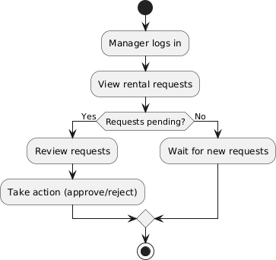

FR31 - Generate Management Reports (Done by: Ornelt Lemellari)

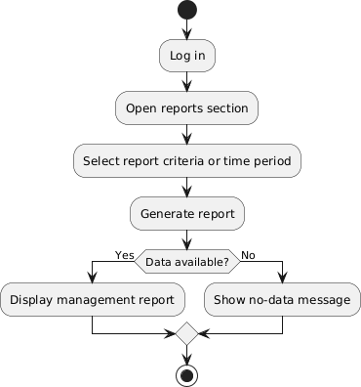

FR32 - Approve Large Discounts and Promotions (Done by: Ornelt Lemellari)

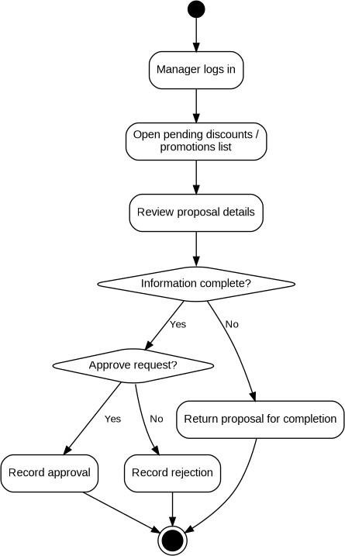

FR33 - Review Complaints and Forward Unresolved Issues (Done by: Ornelt Lemellari)

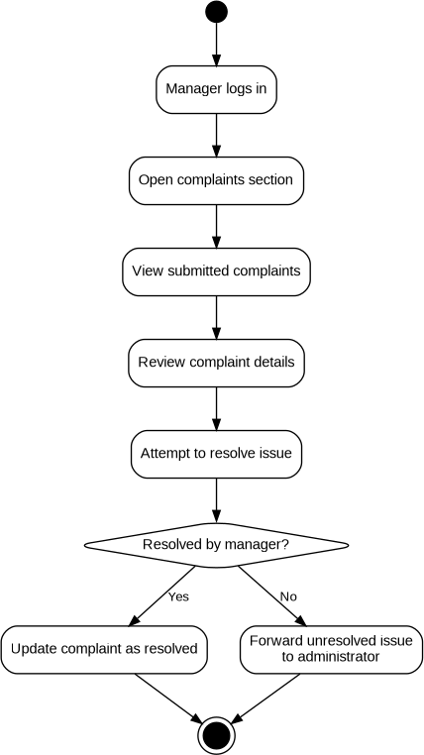

Financier
FR34 - View Transaction History (Done by: Ornelt Lemellari)

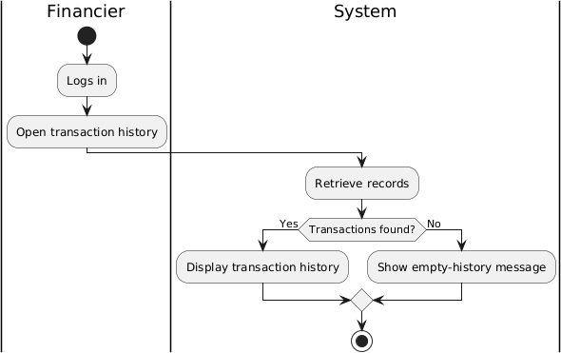

FR35 - Monitor Payment Process and Security (Done by: Ornelt Lemellari)
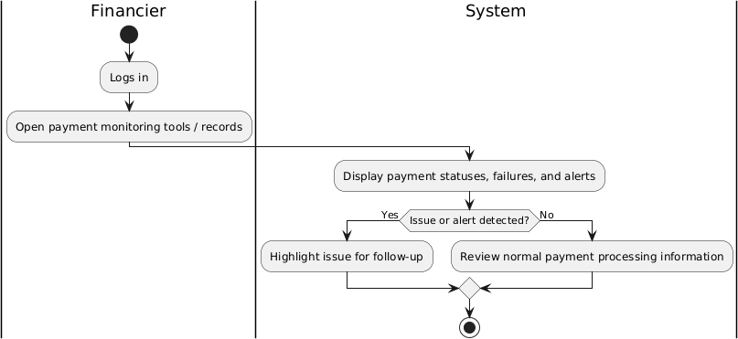

FR36 - Communicate Payment Issues with Tenants and Owners (Done by: Ornelt Lemellari)

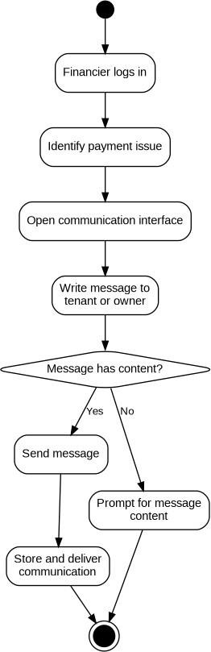

FR37 - Approve Refunds for cancelled Rental Transactions (Done by: Kevin Muho)

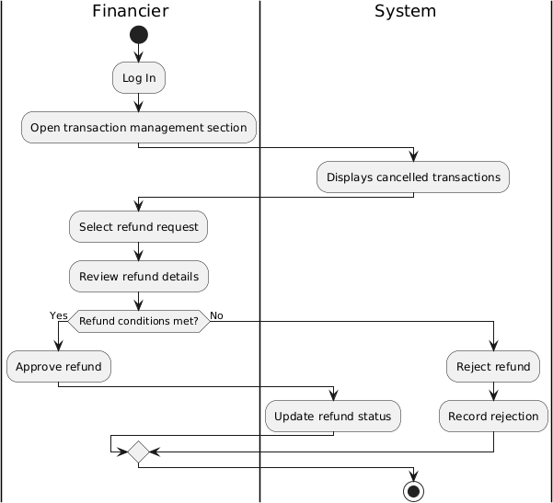

Human Resources (HR)
FR38 - Manage Complaints (Done by: Kevin Muho)

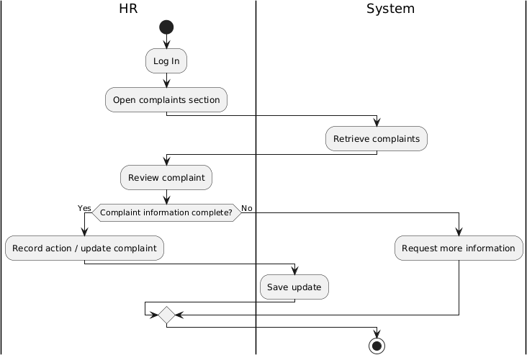
FR39 - Send Notifications and Reminders (Done by: Kevin Muho)

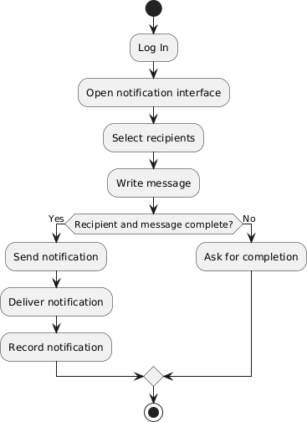

FR40 - Maintain Records of User Issues and Resolutions (Done by: Kevin Muho)

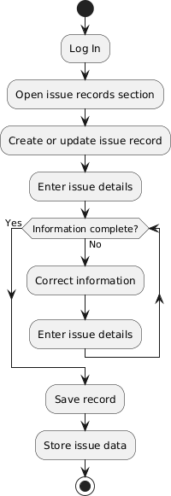

User (these 2 processes are the same for all 6 actors. All actors inherit from UCT of user)

FR41 - Register Account (Done by: Kevin Muho)

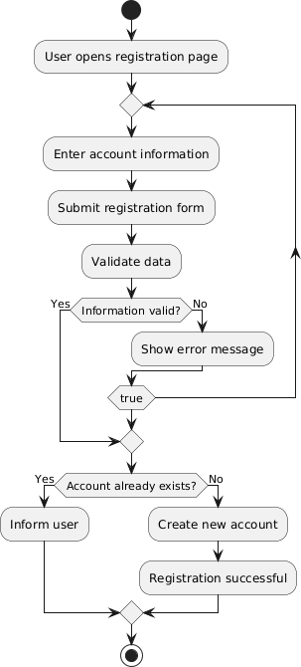

FR42 - Log In (Done by: Kevin Muho)

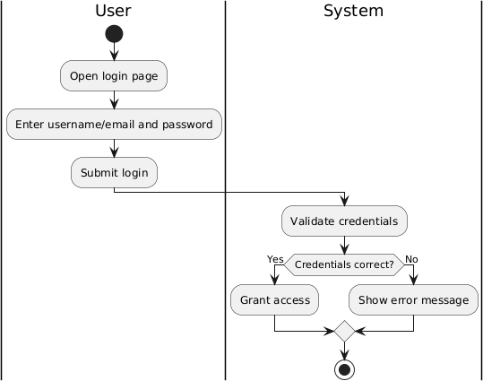

FR43 – Log Out (Done by: Kevin Muho)

